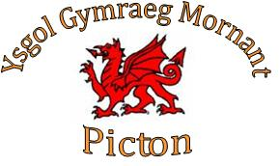
Ysgol Goedwig

Ffurflen Meddygol
Enw’s Plentyn ………………………………………………………………………………..
Cyfeiriad ………………………………………………………………………………………..
………………………………………………………………………………………………………
Hanes Meddygol e.e clefyd gwair, asthma
……………………………………………………………………………………………………..
…………………………………………………………………………………………………….
…………………………………………………………………………………………………….
Unrhyw alegredd neu gofynion deiet
……………………………………………………………………………………………………..
…………………………………………………………………………………………………….
…………………………………………………………………………………………………….
Manylion cyswllt mewn argyfwng:
- Enw ……………………………………………………………………………………
Rhif Ffôn …………………………………………………………………………….
- Enw ……………………………………………………………………………………
Rhif Ffôn …………………………………………………………………………….

Manylion Doctor, Enw a Cyfeiriad
……………………………………………………………………………………………………
……………………………………………………………………………………………………

Ysgol Goedwig

Medical Form
Name of Child ………………………………………………………………………………..
Address ………………………………………………………………………………………….
……………………………………………………………………………………………………….
Medical History e.g hay fever, asthma
……………………………………………………………………………………………………..
…………………………………………………………………………………………………….
…………………………………………………………………………………………………….
Any allergies or dietary requirements
……………………………………………………………………………………………………..
……………………………………………………………………………………………………..
………………………………………………………………………………………………………
Emergency Contact Details:
- Name: ……………………………………………………………………………………
Phone Number: ……………………………………………………………………….
- Name: …………………………………………………………………………………….
Phone Number: ……………………………………………………………………….

Doctor’s Details, Name and Address
……………………………………………………………………………………………………
……………………………………………………………………………………………………

